GETTING SPECIFIC RESOURCES

- Edit RestaurantsController.cs
- Edit IRestaurantsService.cs
- Edit RestaurantsService.cs
- Edit IRestaurantsRepository.cs
- Edit RestaurantsRepository.cs
- Edit Restaurants.API.http (this is to test the code is working or not)

STEP BY STEP TUTORIAL

- Edit RestaurantsController.cs to add HttpGet for id
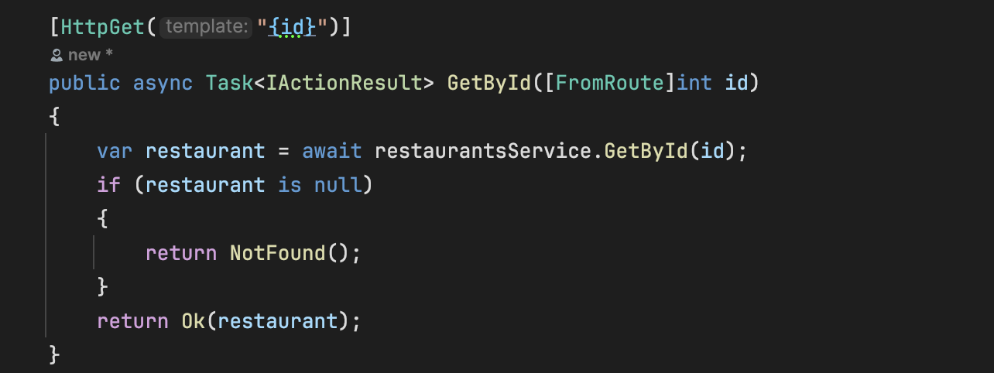
- Add a new method to the restaurant service contract to retrieve a restaurant by its ID IRestaurantsService.cs
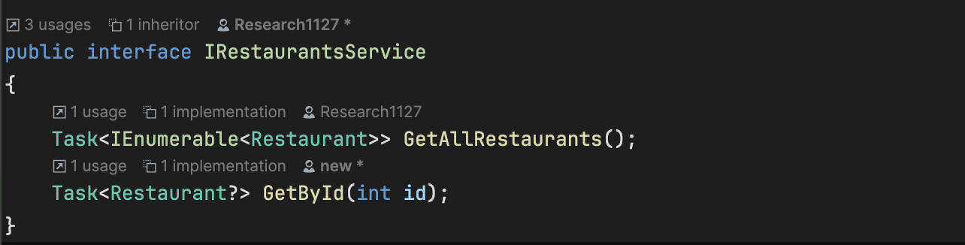
- Implemented GetById method to RestaurantsService.cs
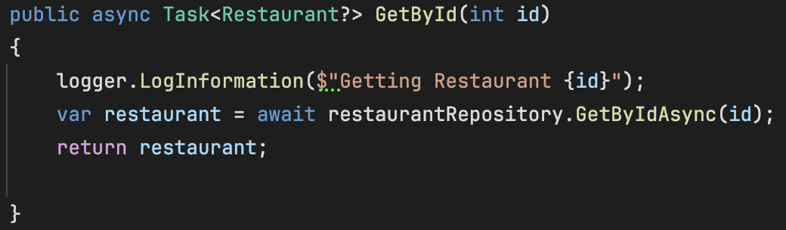
- Added GetByIdAsync method to IRestaurantsRepository.
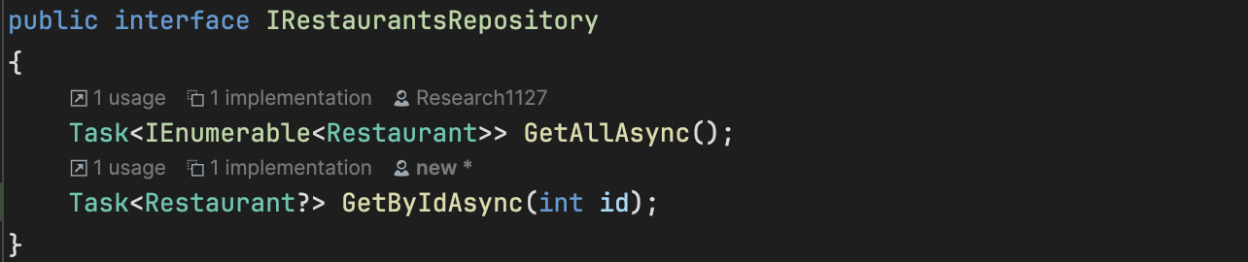
- Implemented GetByIdAsync method in RestaurantsRepository.cs. This defines a contract for retrieving a restaurant by its ID asynchronously. Any class implementing this interface must provide this functionality.
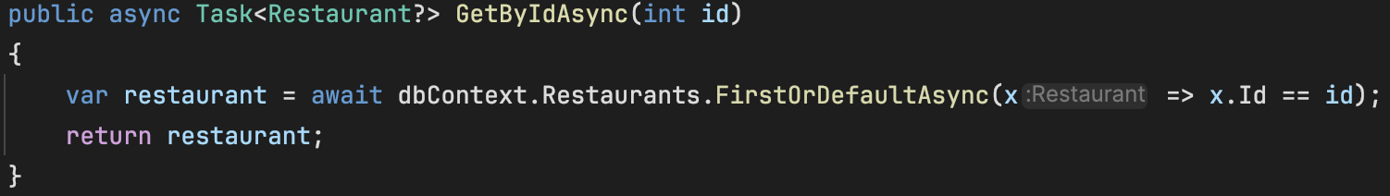

- Edit Restaurants.API.http (this is to test the code is working or not)
